Overview
This process documentation is to assist with supervisor and alternate supervisor time card approval.

Timesheet Submission Deadlines:
Pay period ends on Saturday.
Bi-Weekly employees must submit their time by Sunday at midnight.
Supervisors must review and approve their bi-weekly employees’ time by Monday at 9:00 am.

Step 1
- Watch email for an indication that your employee(s) have submitted their time.

Step 2
2a. In a web browser go to WebAdvisor and login
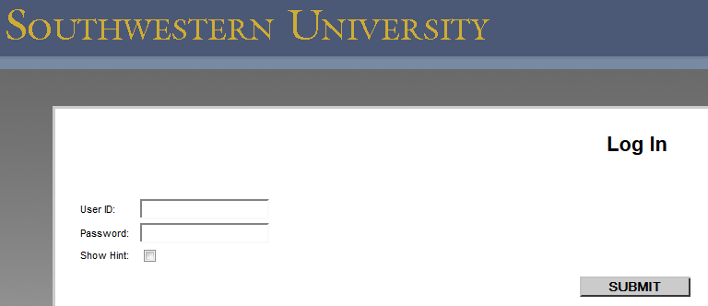

2b. Click on Employees

2c. Click on Time approval
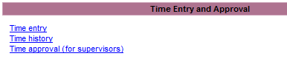

2d. Alternate Supervisors Only (See separate instructions for additional information)
- Select the supervisor’s name for whom you are approving time. When you have selected the name of the supervisor, you’ll see the employees for that supervisor.
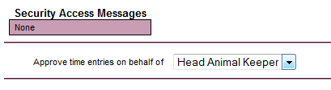

Step 3
3a. The following will be displayed:
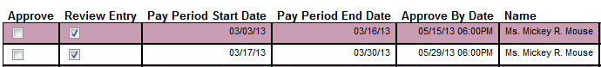

3b. Click on “Review Entry” for the position you are approving time for.
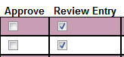

3c. Click on “Submit” to access employee’s time card

Step 4
4a. As the supervisor or alternate supervisor you have edit privileges to change the employee’s time.
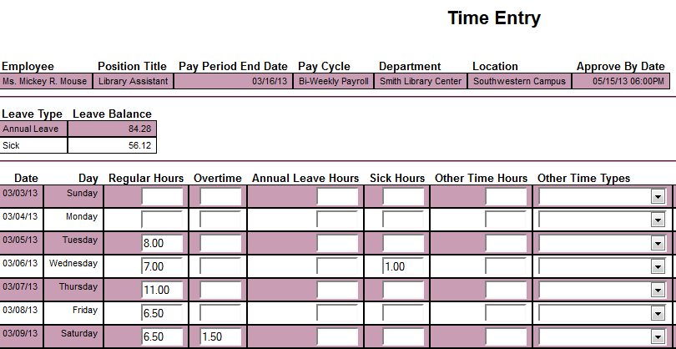

4b. Click in the box to review Time In and Time Out for the employee.

4c. If you select the box in Step 4b to view the time in and time out detail for the employee, you will see the following:
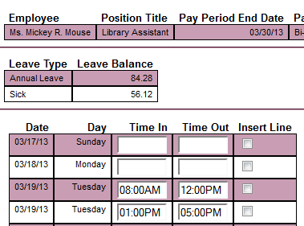

4d. (OPTIONAL) Insert line if needed.
Two lines for each day appear automatically. To enter more than two lines for a day, you may insert another line by clicking on Insert Line. This may be necessary if your employee worked in the same job three times in one day. Example 1: The employee worked in the morning, went to lunch, worked in the afternoon, left for dinner/supper, but returned in the evening.
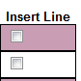

Step 5
5. Verify that the employee has signed their time card
- You will see the following message if the employee has signed their time entry

Step 6
6. Approve or Reject the time card.
- Drop down the Supervisor Decision box and select Approve to approve the time card or Reject to reject the time card.
- NOTE – Please do not “reject” the employee’s time if the employee deadline of Sunday at midnight is already over, because the employee will not be able to make changes. Any bi-weekly employee changes that need to be made after Sunday at midnight must be made by the supervisor.

Step 7
7. (OPTIONAL) Complete an email Subject Line and enter comments. This is especially important if rejecting the time card. It provides an opportunity to direct the employee how to best make a correction. If you do not enter a subject line or make comments a generic email text will be sent to the employee.
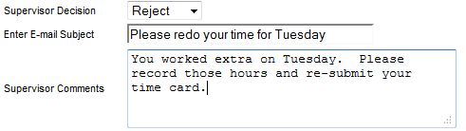
Step 8
8a. An email is sent to the employee using the comments entered in Step 7 above or the generic email if no comments were entered.
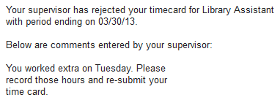

8b. If the time was rejected, watch for another email as in Step 1 indicating that the employee completed the time entry process. Repeat the approval process, this time marking the time as approved. After the time is approved an indicator will appear in payroll on a report and on their view of the time card.

Step 9
9a. SUBMIT

9b. Confirmation appears.
- Click on OK

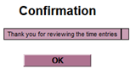
9c. LOGOUT
9d. The employee will receive an email indicating that you have approved their timesheet.

NOTE: If the bi-weekly employee does not submit his/her time online by the deadline shown on page 1 (Sunday at midnight), a paper timesheet must still be completed by the employee, approved by the supervisor, and submitted to the Business Office on Monday by 5 pm. (Part-time employees will not be paid hours submitted on a paper timesheet until the next scheduled payroll period.)

Please contact either Brenda Thompson at 863-1956 or thompso2@southwestern.edu or Janie Litton at 863-1932 or Litton@southwestern.edu with questions.

