Overview
This process documentation is to assist employees with time entry.
Time should be entered on a daily basis as worked.

Time Entry Deadline
Pay period ends on Saturday.
Full-time Employees are expected to work 40 hours per week (Sunday – Saturday).
Time must be entered online by the next day, Sunday, at 12:00am (midnight).

Step 1
1a. In a web browser go to WebAdvisor and log in.
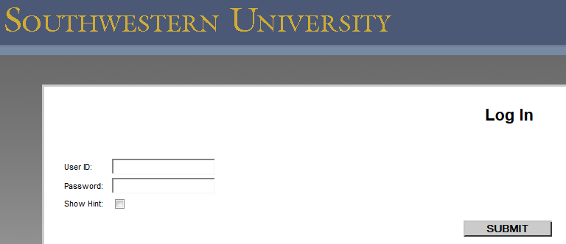

1b. Click on Employees.
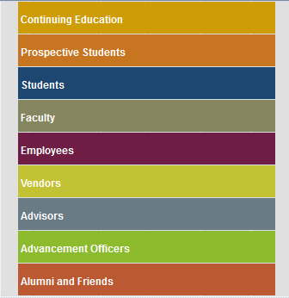

1c. Click on the Time Entry link.
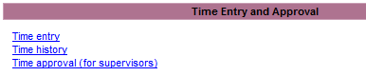

Step 2
2a. You will see the following screen:
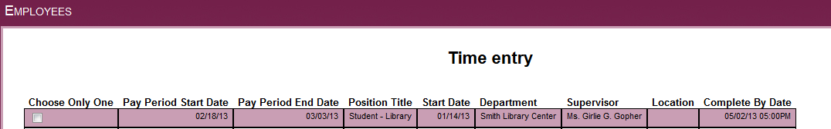
Step 2b

2b. Click the box under “Choose Only One” for the position for which you are entering time.
- (If you have more than one job, there will be multiple listings on the screen shown in Step 2a above.)
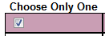

2c. Click on SUBMIT to access time card.

Step 3
3a. The following will be displayed. Note that your CURRENT Vacation & Sick Leave balances are shown on this page.

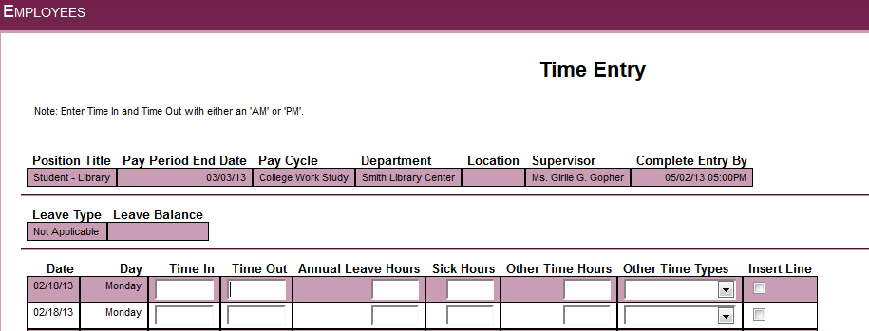
Step 3c
Step 3b
3b. Enter Time In and Time Out for the appropriate dates.
- Enter time with ‘a’ or ‘am’, or ‘p’ or ‘pm’.
  - Example 1: 9:00 in the morning is entered as 9:00am or 9a
  - Example 2: 4:00 in the afternoon is entered as 4pm or 4p
  - Example 3: 1:30 in the afternoon can be entered as 0130pm or 1:30p
3c. (OPTIONAL) Insert line if needed.
- Two lines for each day appear automatically. You can insert a line if needed by clicking on Insert Line and by clicking Submit at bottom of page.
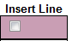
3d. Annual Leave Hours and Sick Hours
- If you took vacation (Annual Leave Hours) or sick (Sick Hours) time you will record the number of hours taken for that particular day in the appropriate column.
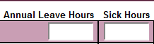

3e. Other Time Hours and Other Time Types
- If you took hours for any of the following reasons record the number of hours in the Other Time Hours column and select the appropriate type in the Other Time Types
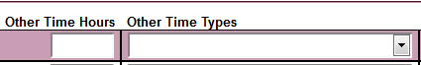
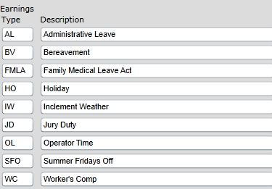

Step 4
4a. Submit the time entered. Click on SUBMIT to save your information.
- Note: Time should be entered during each shift, as you work.
4b. You will then see the following:
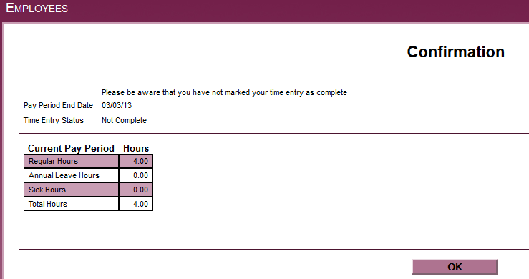
4c. Verify that the total number appearing in the “Total Hours” box is correct for the
cumulative hours worked for the days entered in the system. (You will not see an amount per day or per week, only a cumulative hour number.)
4d. Click OK to close.
Step 5
5a. Once all time is entered for the pay period you will “sign” the time card by clicking on the signature box (located underneath the time-in and time-out section)
5b. Confirmation screen appears
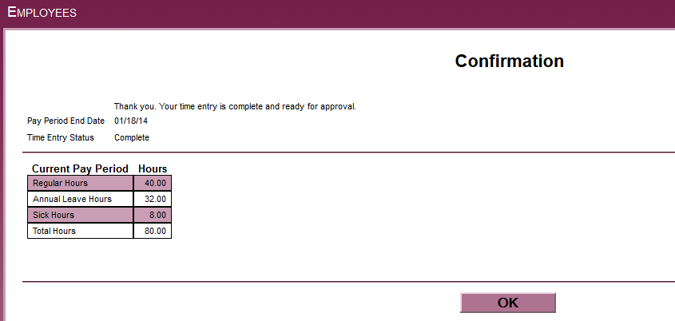
5c. Click OK TO CLOSE.
5d. Log out.
Step 6
Watch email for approval or rejection of time card. Once submitted, you will not have access to this time card again unless your supervisor rejects your time card. If your time card is rejected you will log in and fix any errors and re-submit.
Note – If your time is not submitted by the deadline (Sunday at 12am), you will no longer be able to enter it online for that payroll period. However, your Supervisor may make any needed adjustments to your time card until Monday at 9am. If neither takes place, a paper timesheet must be completed, approved by your supervisor, and submitted to the Business Office by Monday at 5 pm. (Part-time employees will not be paid hours submitted on a paper timesheet until the next scheduled payroll period.)
Please contact Janie Litton at 863-1932 or littonj@southwestern.edu with questions.
Time History
You can select the Time History option shown below to see any time card (prior or current).
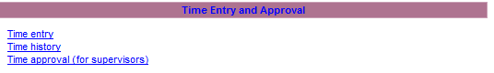
When you select Time History you will be able to select the calendar year you want to view.
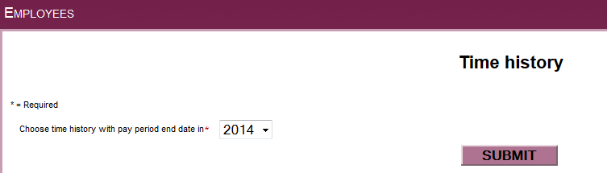
Once you click Submit all your time cards for the calendar year will be visible as shown below. Select time card you wish to view by checking the box under the ‘Choose Only One’ Column.
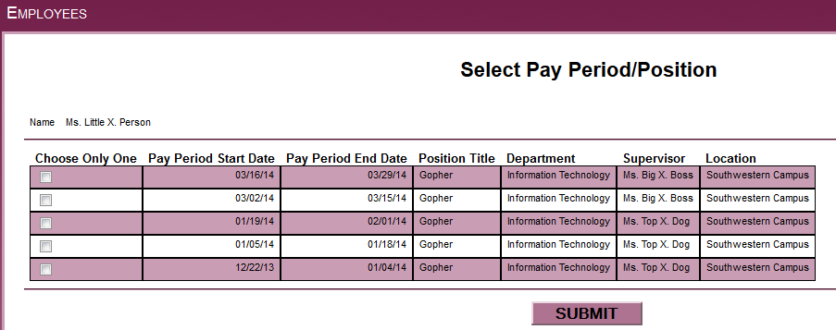
You can review your current time card to see summary hours by day even prior to signing the time card as complete. Example below:
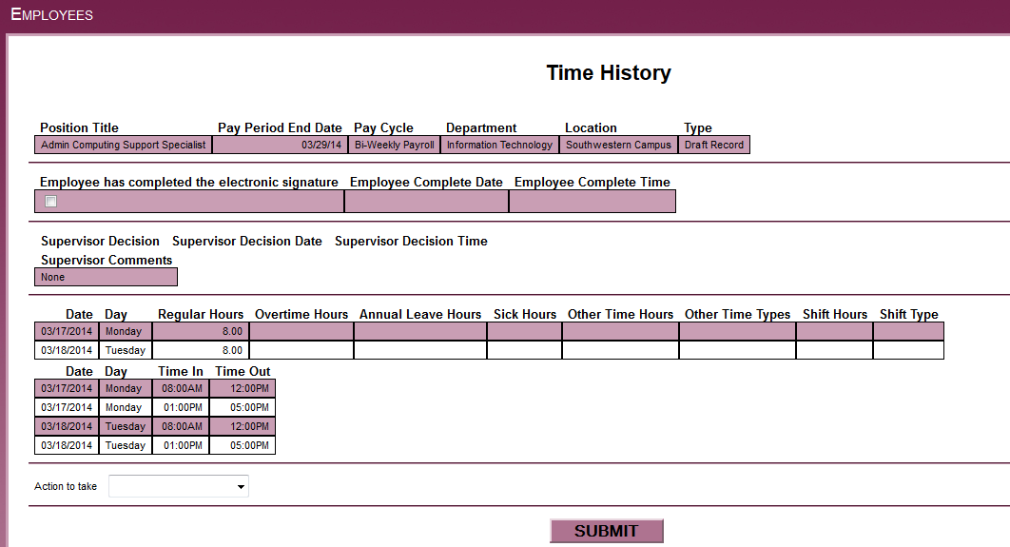
You cannot make any changes to these records. They are view only. To exit from this view, simply click on one of the tabs at the top of the page.

